Student name: Mithila Kamaraj

ITWD5.130: Website Development Assignment 2 Project Storyboard

Contents

Preliminary design 4

SITE TOPIC 4

WEBSITE NAME 4

PURPOSE: 4

CONTENT (main features) 4

TARGET AUDIENCE 4

Concept Design 5

Concept 1 5

Concept 2 6

Concept 3 7

The preferred concept and why? 8

Navigation Map 9

Generic Section/template 10

Page Detail 11

Page 1 11

Page 2 12

Page 3 13

Page 4 14

Page 5 15

Page 6 16

Page 7 17

Page 8 18

Page 9 19

Schedule of Elements 20

Statement of Authenticity 21

# Preliminary design

SITE TOPIC**:** My website is similar to a blog website with vintage as my topic.

WEBSITE NAME**:** Roads to vintage

PURPOSE:The main purpose of this website is to give information, share ideas and experiences, help people and connect with others having similar likings.

CONTENT (main features)**:** My website will have all the information about the best vintage items and also some information on where to buy vintage items in New Zealand. In total I have 9 pages. Each page will contain the best vintage items for that particular category (i.e. clothing, home décor and cars) with some description about it. One of my pages will also have famous designers of different centuries displayed using a timeline element.

Other features include having a contact form for my viewers and readers to get in touch with me, having slideshows to display items in my website and a page with different links to other famous and interesting blogs about vintage.

TARGET AUDIENCE**:** My site is designed for anyone interested in vintage or looking to buy vintage items in New Zealand. And also for others who share the love for vintage and writing their own blogs and articles on vintage. It designed for both the genders as anyone can be interested in home décor and cars. The age range of the audience is for anyone in their teenage or beyond focusing on all ethnicities, cultures and languages.

# Concept Design

## Concept 1

Home Page:

|  |
| --- |
| **ADVANTAGES:**   1. Even spacing of all the elements in the page. 2. Background and colors dedicated for the page suits the topic “vintage”.   **DISADVANTAGES:**   1. Color contrast between the background image and the text is not that great. So when text overlays the image it may not be visible. |

Information Page:

|  |
| --- |
| **ADVANTAGES:**   1. Usage of timeline element in this page makes it look professional and legit. 2. Gradient background color dedicated for information suits the topic “vintage” and text overlaying it is clear and visible.   **DISADVANTAGES:**   1. The font style used for this page may not be that great |

## Concept 2

Home Page:

|  |
| --- |
| **ADVANTAGES:**   1. Usage of timeline element in this page makes it look professional and legit. 2. Contrast between the text color and the background color is great making it visible.   **DISADVANTAGES:**   1. There is a lot empty spaces not being used 2. The whole webpage style looks very simple and may appear uninteresting. |

Information Page:

|  |
| --- |
| **ADVANTAGES:**   1. Usage of timeline element in this page makes it look professional and legit.   **DISADVANTAGES:**   1. The colors used are dull and may not be appealing to the viewers. |

## Concept 3

Home Page:

|  |
| --- |
| **ADVANTAGES:**   1. Very simple and easy to read and understand   **DISADVANTAGES:**   1. There is a lot empty spaces not being used 2. The whole webpage style looks very simple and may appear uninteresting. 3. Colors don’t match the topic chosen. |

Information Page:

|  |
| --- |
| **ADVANTAGES:**   1. Usage of timeline element in this page makes it look professional and legit.   **DISADVANTAGES:**   1. The colors used does not suit the concept 2. It is a scrolling down website which may not be a great idea. |

# The preferred concept and why?

|  |
| --- |
| My preferred concept is concept 1 because the design will be more appealing to the viewers as it has good background images and colors that suits my topic. And there is no wastage of space as all elements are evenly spaced in the website making it a professional looking website.  Other reasons for choosing that design include more viewers outside the target audience will be attracted to the website than the design used in concept 2. And the concept three is a scrolling down concept which may not be suitable as there is of information given in the website and even the colors may not be attractive to the audience and does not suit the topic. |

# Navigation Map

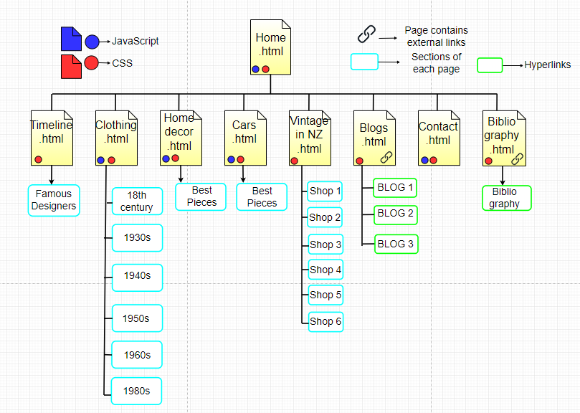

# Generic Section/template

Screen Size:

800*600 pixels

Text color:

Black

Text Font family:

Lucida Console, Monaco, monospace

Background for Home Page:

A background image.

Background for other pages:

Background color – gradient of “663300” (west).

Navigation:

Every page has the same navigation bar on top and when scrolled it will stick to the top of the screen.

Footer:

Every page has a footer with a link containing to the bibliography and when clicked, it will open up a new page containing all the references.

Headings (Home page):

Home page does not have a page

Headings (other pages):

Each page has a page heading at top right corner of the page.

Logo (Other Pages):

Logo on other pages are positioned on the top left corner.

Interaction:

When pointer moved over any buttons or navigation options, it change to a different color (light up).

# Page Detail

## Page 1

+ File name: Home.html

|  |
| --- |
| Elements:   * Logo * Search box * Navigation * Images * Buttons * Paragraph * Footer * Background image   Special fonts and colours or animations:   * Slide show   Other Comments for developer:   * When button is clicked it should show next image. * When bibliography is clicked it will open a new page. |

## Page 2

+ File name: timeline.html

|  |
| --- |
| Elements:   * Logo * Search box * Page heading * Navigation * Timeline bar * Photo * Heading * Paragraph * Buttons which display some text, an image, and year, when clicked;   Special fonts and colours, animation:   * None.   Other Comments for developer:   * When bibliography is clicked it will open a new page. * Should contain seven time line buttons. |

## Page 3

+ File name: clothing.html

|  |
| --- |
| Elements:   * Logo * Page heading * Navigation * Timeline bar * Buttons which display some text and year, when clicked * Photo * Heading * Paragraph   Special fonts and colours, animation:   * None.   Other Comments for developer:   * When bibliography is clicked it will open a new page. * The timeline bar is vertical. * Clicking a second button should hide text/images from the previous button first. * Should contain seven time line buttons. |

## Page 4

+ File name: homeDecor.html

|  |
| --- |
| Elements:   * Logo * Page heading * Navigation * Heading * Images * Buttons * Paragraph * Footer   Special fonts and colours or animations:   * Slide show   Other Comments for developer:   * When button is clicked it should show next image and its description. * When bibliography is clicked it will open a new page. |

## Page 5

+ File name: cars.html

|  |
| --- |
| Elements:   * Logo * Page heading * Navigation * Heading * Images * Buttons * Paragraph * Footer   Special fonts and colours or animations:   * Slide show   Other Comments for developer:   * When button is clicked it should show next image and its description. * When bibliography is clicked it will open a new page. |

## Page 6

+ File name: vintageInNZ.html

|  |
| --- |
| Elements:   * Logo * Page heading * Navigation * Heading * Grid * Paragraph with list * Footer   Special fonts and colours or animations:   * None   Other Comments for developer:   * When bibliography is clicked it will open a new page. |

## Page 7

+ File name: blogs.html

|  |
| --- |
| Elements:   * Logo * Page heading * Navigation * Heading * Images * Hyperlinks * Paragraph * Footer   Special fonts and colours or animations:   * None   Other Comments for developer:   * When picture is clicked, it will open a different page using an external hyperlink. * When bibliography is clicked it will open a new page. |

## Page 8

+ File name: contact.html

|  |
| --- |
| Elements:   * Logo * Page heading * Navigation * Heading * Paragraph * Contact form * Button * Footer   Special fonts and colours or animations:   * None   Other Comments for developer:   * When bibliography is clicked it will open a new page. |

## Page 9

+ File name: bibliography.html

|  |
| --- |
| Elements:   * Heading * Paragraph * Hyperlinks   Special fonts and colours or animations:   * None   Other Comments for developer:   * Will contain the “privacy policy” section too. |

# Schedule of Elements

|  |  |  |  |  |
| --- | --- | --- | --- | --- |
| Image name: | Image size (kb / mb) | Width | Height | Pages element is used on |
| logo.png | 21.0 KB | 704 pixels | 457 pixels | Every Page |
| quote.png (4) | 156KB | 1000 pixels | 760 pixels | Home Page |
| designer.png (7) | 20.0 KB | 704 pixels | 457 pixels | Timeline Page |
| 18th.png (6) | 102 KB | 340 pixels | 200 pixels | Clothing Page |
| 1920.png (6) | 102 KB | 340 pixels | 200 pixels | Clothing Page |
| 1930.png (6) | 102 KB | 340 pixels | 200 pixels | Clothing Page |
| 1940.png (6) | 102 KB | 340 pixels | 200 pixels | Clothing Page |
| 1950.png (6) | 102 KB | 340 pixels | 200 pixels | Clothing Page |
| 1960.png (6) | 102 KB | 340 pixels | 200 pixels | Clothing Page |
| 1980.png (6) | 102 KB | 340 pixels | 200 pixels | Clothing Page |
| Home.png (5) | 156KB | 1000 pixels | 760 pixels | Home decor Page |
| Car.png (5) | 156KB | 1000 pixels | 760 pixels | Cars Page |
| Blogs.png (5) | 20.0 KB | 704 pixels | 457 pixels | Blogs Page |

# Statement of Authenticity

I confirm that:

* This is an original assessment and is entirely my own work.
* It contains no material previously published or written by another person or myself except where due acknowledgement is made in the text.
* No material which to a substantial extent, has been submitted for any other academic course, is included without acknowledgement.